LAB EXPERIMENT
SET 14: SURVEY RESULTS ANALYSIS

Department | AIDS
Course Code / Course Name | DSA0602 / Data Handling and Visualization
Experiment | Data Visualization using R and Tableau
Name | D.HEMASREE
Register Number | 192524114
Date | 8 October 2026
Day | Thursday

Aim
To analyze survey response data using a stacked bar chart, a radar chart and a response table in R, and to build an interactive dashboard using Tableau. Dataset: Survey Results

Respondent | Question 1 | Question 2 | Question 3
1 | A | B | C
2 | B | A | D
3 | C | A | B

PROGRAM 1: Stacked Bar Chart of Question 1 Answers
Create a stacked bar chart to display the distribution of answers for Question 1. Label the chart elements.
library(ggplot2)

survey <- data.frame( Respondent = 1:3,
Question_1 = c("A", "B", "C"),
Question_2 = c("B", "A", "A"),
Question_3 = c("C", "D", "B")
)

ggplot(survey, aes(x = "Question 1", fill = Question_1)) + geom_bar(width = 0.5) +
geom_text(stat = "count", aes(label = after_stat(count)),
position = position_stack(vjust = 0.5), color = "white") + scale_fill_manual(values = c(A = "steelblue", B = "darkorange",
C = "forestgreen")) + scale_y_continuous(breaks = 0:3) +
labs(title = "Distribution of Answers for Question 1", x = "Question",
y = "Number of Respondents", fill = "Answer")

OUTPUT:
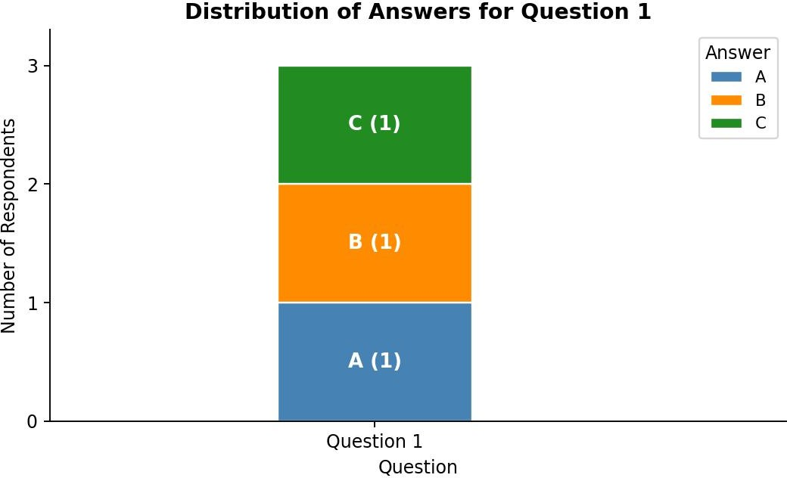

Output 1: Distribution of Answers for Question 1 (Stacked Bar Chart)
Observation: Each of the three answers A, B and C was chosen by exactly one respondent, so each takes one third (33.3%) of the stacked bar. No answer is more popular than another for Question 1, and no respondent chose D.

PROGRAM 2: Radar Chart of Response Pattern
Generate a radar chart to visualize the overall pattern of responses across all three questions.
library(fmsb)

survey <- data.frame( Respondent = 1:3,
Question_1 = c("A", "B", "C"),
Question_2 = c("B", "A", "A"),
Question_3 = c("C", "D", "B")
)

lv <- c("A", "B", "C", "D")
counts <- sapply(survey[, -1],
function(x) table(factor(x, levels = lv)))

radar_data <- rbind(rep(2, 3), rep(0, 3), counts) radar_data <- as.data.frame(radar_data)
colnames(radar_data) <- c("Question 1", "Question 2", "Question 3") colors <- c("steelblue", "darkorange", "forestgreen", "purple")
radarchart(radar_data,
axistype = 1,
seg = 2,
caxislabels = 0:2, pcol = colors,
plwd = 2,
plty = 1,

cglcol = "grey",
title = "Response Pattern Across Questions") legend("topright",
legend = c("Option A", "Option B", "Option C", "Option D"), col = colors, lty = 1, lwd = 2)

OUTPUT:
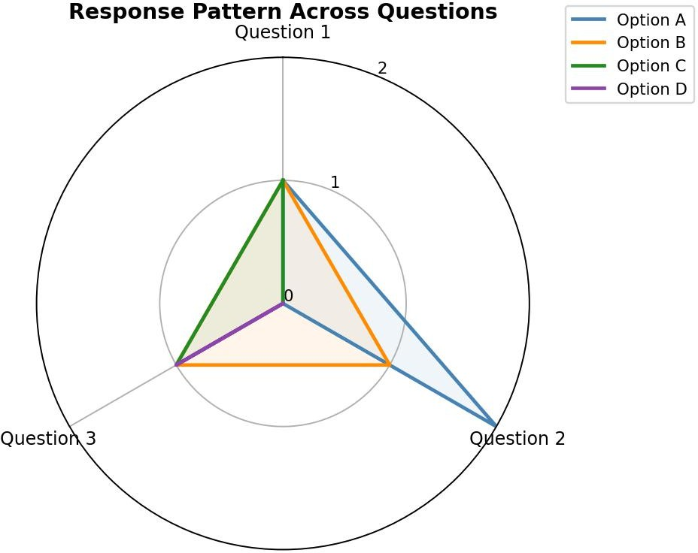
Output 2: Response Pattern Across Questions (Radar Chart)
Observation: Each axis is a question and each line is an answer option, with the distance from the centre showing how many respondents chose it. Option A is the most common answer for Question 2 (2 of 3 respondents). Question 1 is split evenly across A, B and C. Question 3 is spread across B, C and D, and D appears only there. Option B is chosen exactly once for every question.

PROGRAM 3: Table of Survey Responses for Each Respondent
Build a table to show the survey response data for each respondent. Label the table elements.
survey <- data.frame( Respondent = 1:3,
Question_1 = c("A", "B", "C"),
Question_2 = c("B", "A", "A"),
Question_3 = c("C", "D", "B")
)

print(survey)

lv <- c("A", "B", "C", "D")
sapply(survey[, -1], function(x) table(factor(x, levels = lv)))

OUTPUT:
Console Output
Respondent Question_1 Question_2 Question_3
- 1 A B C
- 2 B A D
- 3 C A B

Question_1 Question_2 Question_3 A 1 2 0
B 1 1 1
C 1 0 1
D 0 0 1

Output 3a: Survey Response Table (R Console)

Respondent | Question 1 | Question 2 | Question 3
1 | A | B | C
2 | B | A | D
3 | C | A | B
Output 3b: Survey Response Table

Answer | Question 1 | Question 2 | Question 3
A | 1 | 2 | 0
B | 1 | 1 | 1
C | 1 | 0 | 1
D | 0 | 0 | 1
Total | 3 | 3 | 3
Output 3c: Response Count for Each Answer
Observation: The first table gives the exact answers of each respondent to each question. The count table shows how many respondents chose each option. All three respondents answered every question. Option A for Question 2 is the only answer chosen by more than one respondent, and option D was chosen just once (Question 3).

PROGRAM 4: Interactive Survey Dashboard in Tableau
Develop a Tableau dashboard combining the stacked bar chart, radar chart and the table for interactive exploration of survey responses.

Steps in Tableau
- Save the survey data as an Excel or CSV file and connect to it in Tableau (Connect > Microsoft Excel / Text file). Select the Question 1, Question 2 and Question 3 columns, right-click and choose Pivot, then rename the new fields to "Question" and "Answer".
- Sheet 1 (Stacked Bar Chart): Drag Question to Columns and Number of Records (or COUNT of Respondent) to Rows. Drag Answer to Color and Label, and filter Question to Question 1. Rename the sheet "Question 1 Distribution".

- Sheet 2 (Radar Chart): Tableau has no built-in radar chart, so build it with calculated fields. Create Angle (Question 1 = 90, Question 2 = 210, Question 3 = 330), Count (COUNT of Respondent), X = [Count] * COS(RADIANS([Angle])) and Y = [Count] * SIN(RADIANS([Angle])). Drag X to Columns and Y to Rows, set Marks to Polygon, drag Answer to Color and Detail, and drag Question to Path. Rename the sheet "Response Pattern".
- Sheet 3 (Table): Drag Respondent to Rows, Question to Columns and Answer to Text. Rename the sheet "Response Table".
- Create a new Dashboard (Dashboard > New Dashboard), set the size to Automatic, and drag the three sheets onto the dashboard area.
- Add interactivity: select each chart and click Use as Filter, so clicking an answer or respondent in one view filters the others. Add Respondent and Answer filters (Show Filter > Apply to Worksheets > All Using This Data Source).
- Add the title "Survey Results Dashboard" and test the filters in Presentation Mode.

OUTPUT:
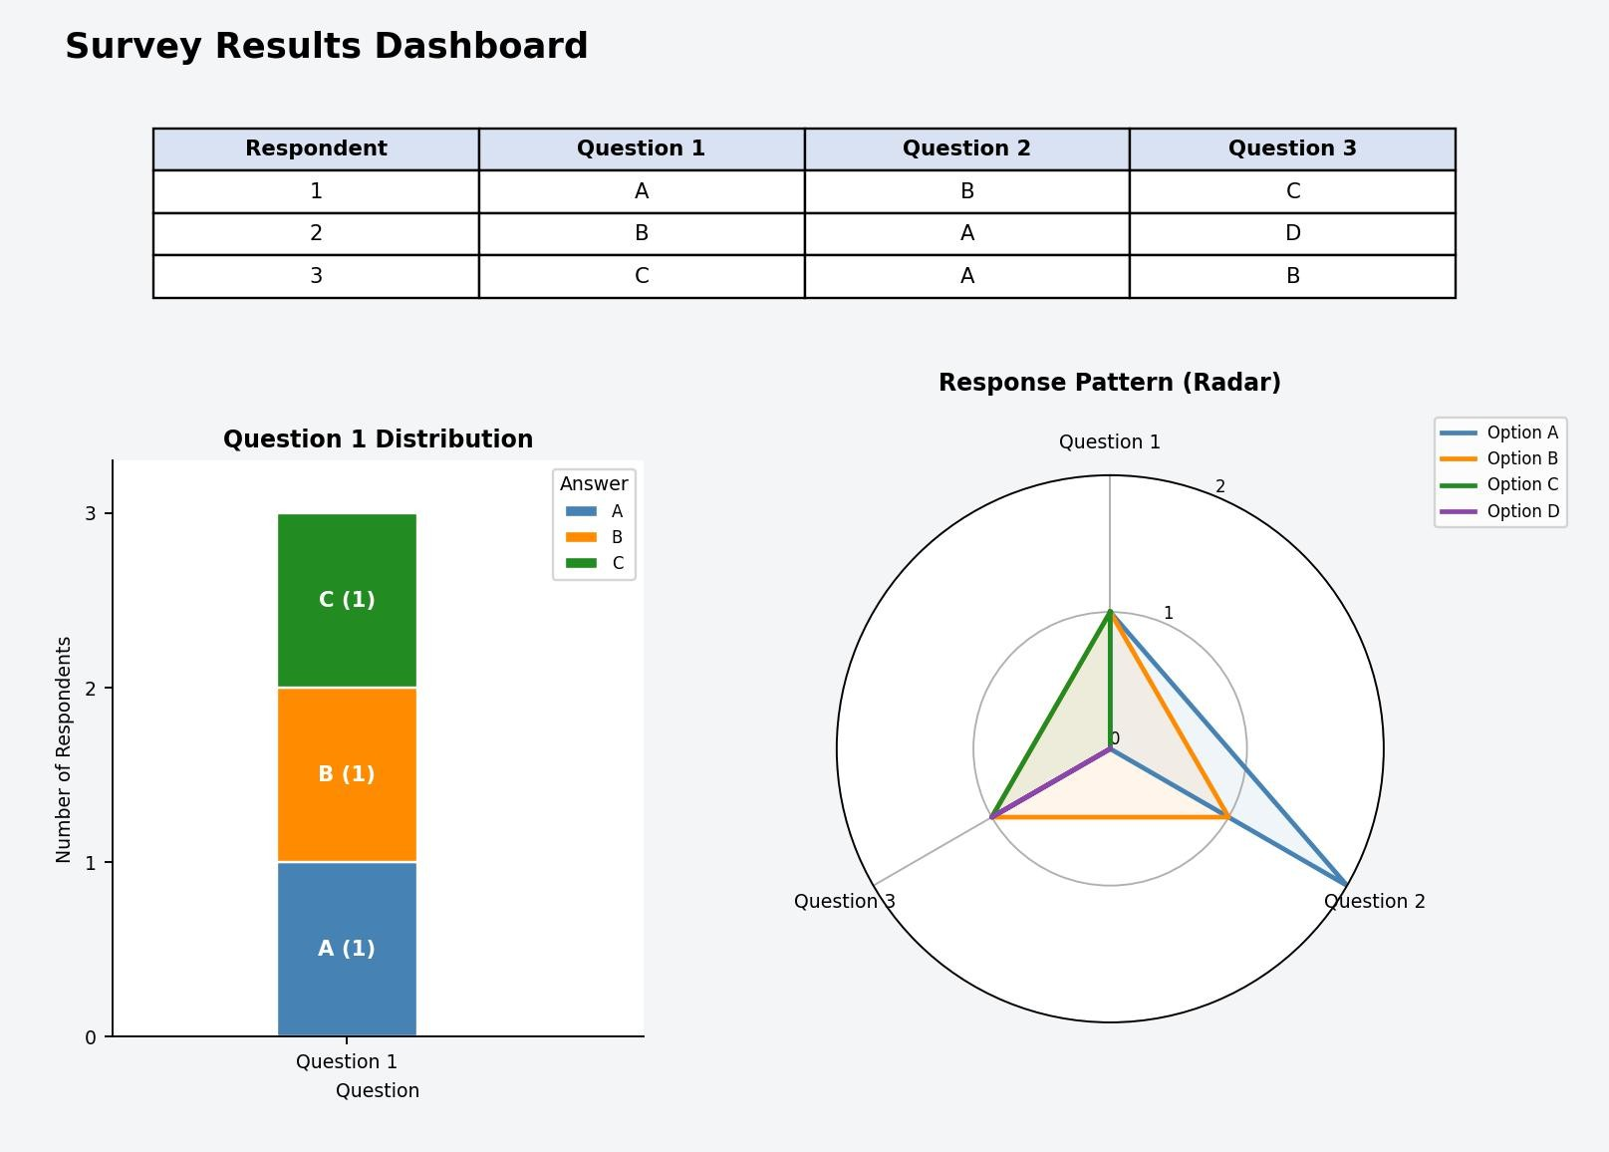
Output 4: Interactive Survey Results Dashboard (Tableau)
Observation: The dashboard shows the Question 1 distribution, the overall response pattern and the response table together. Selecting a respondent or an answer in any view filters the other two.

Procedure
- Define the survey responses in R as a data frame with Respondent, Question_1, Question_2 and Question_3.
- Use ggplot2 with geom_bar() to create the stacked bar chart of the Question 1 answers.
- Count each answer option for every question with table() and sapply(), and draw the counts with radarchart() from the fmsb package.

- Display the survey data with print() and show the answer counts as a table.
- Load the survey file into Tableau, pivot the question columns, and build the stacked bar chart, radar chart and table worksheets.
- Combine the worksheets in a Tableau dashboard and add filters and actions for interactivity.

RESULT:
The survey response data was successfully analyzed using a stacked bar chart, a radar chart and a response table in R. An interactive Tableau dashboard was also created, combining all three views so that users can explore the survey responses by question, answer and respondent.

Key Functions and Tools Used

Function / Tool | Purpose
data.frame() | Creates the survey response table.
ggplot() / geom_bar() | Creates the stacked bar chart.
table() / sapply() | Counts how many respondents chose each answer.
radarchart() (fmsb) | Creates the radar chart of the response pattern.
print() | Displays the survey response table.
Tableau Pivot | Converts the question columns into Question and Answer fields.
Tableau Dashboard | Combines worksheets with filters and actions.

